Roma Graduate Preparation Program 2014-2015 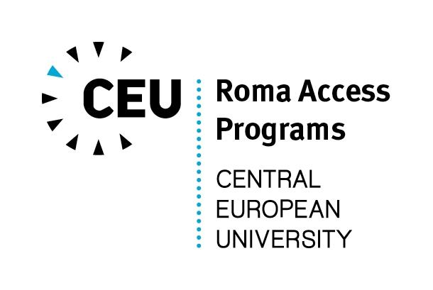
template for reference letter (to be filled out by referee)

Name of the applicant: _____________________________________________

Name of the referee: _____________________________________________

Institution: _____________________________________________

Position: _____________________________________________

Contacts (preferably e-mail or phone number): ____________________________________

Dear Sir/Madam,
The above person is applying for the Roma Graduate Preparation Program of the Central European University, which is a 9-month preparatory program for Roma students who wish to continue their studies in English-language Master’s programs in social sciences. Could you please briefly describe in your recommendation letter the following:

- your connection to the person you are recommending, including how you know him/her, since when, and in what capacity have you been working with the applicant
- what are the applicant’s qualifications that make him/her suitable for graduate studies
- in what way would the Roma Graduate Preparation Program and graduate studies be useful in the applicant’s academic and professional career

Thank you very much!

(please feel free to continue on additional pages)

